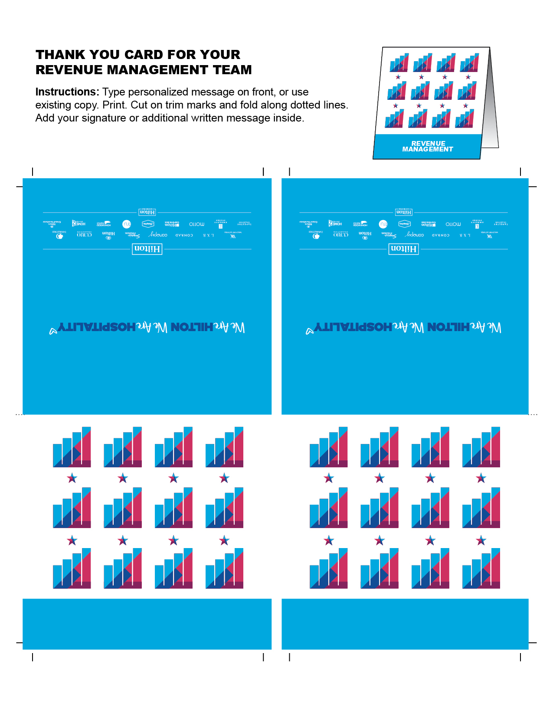

REVENUE

MANAGEMENT

REVENUE

MANAGEMENT