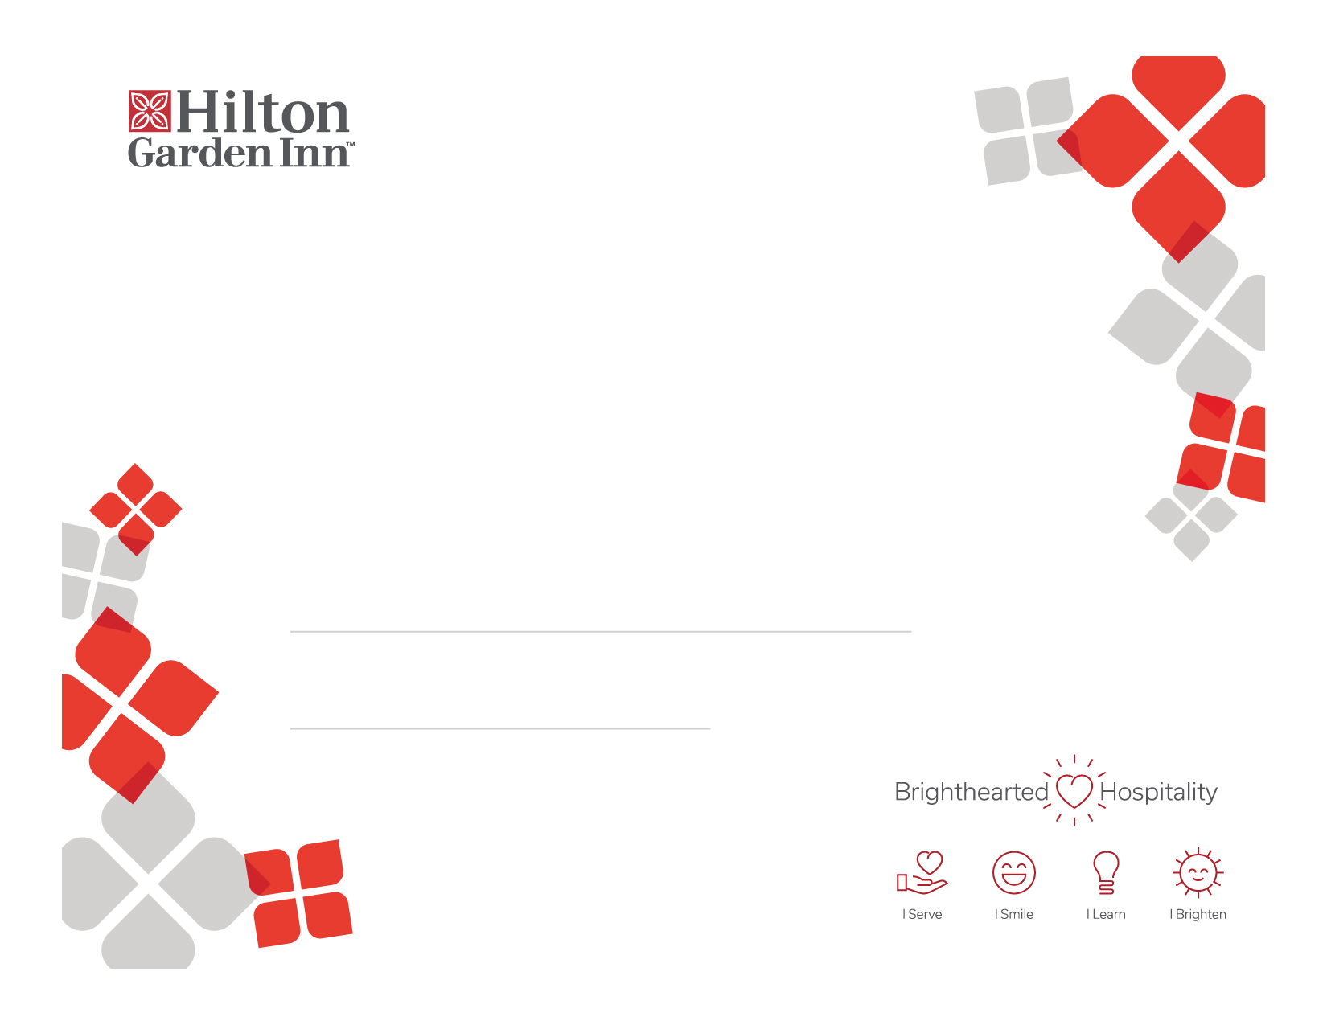

Type Name Here

e

Certificate of Recognition

e

Date

Name/Title

Type achievement here. You have up to two lines for this information.

Presented to: