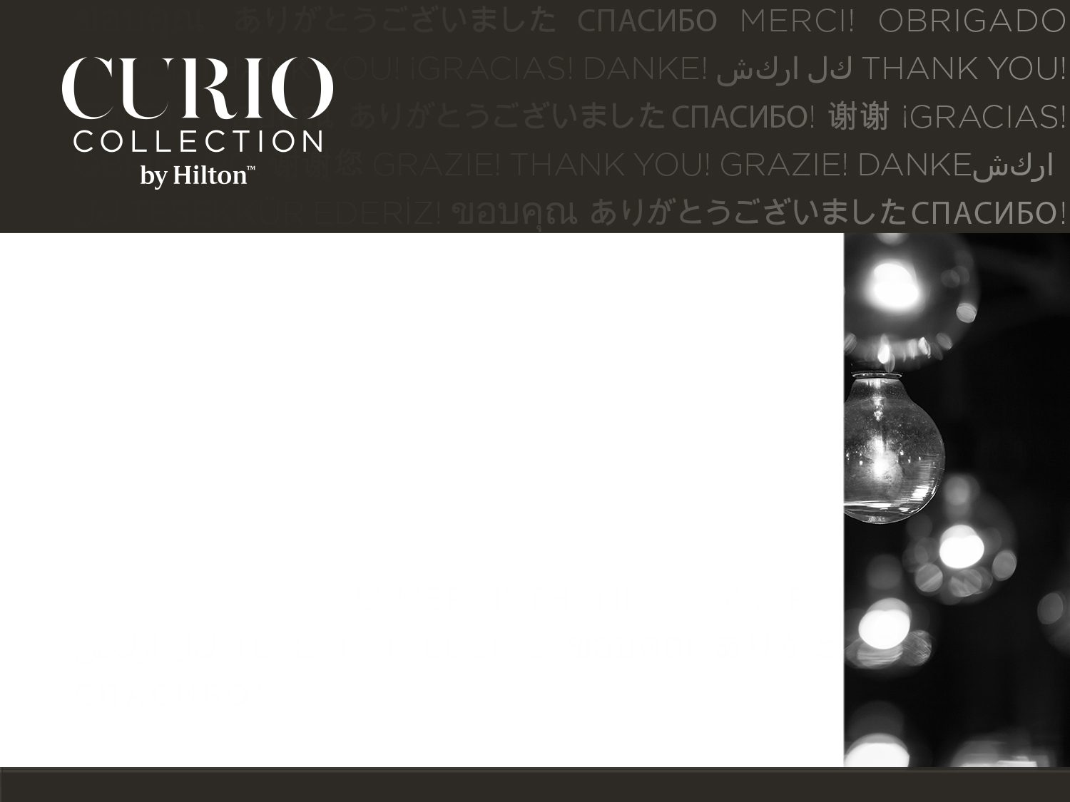

Type Name Here

−Type Sender’s Name Here

Type your message here. All content is customizable, including

language. You can use up to five lines.

HIGH FIVE