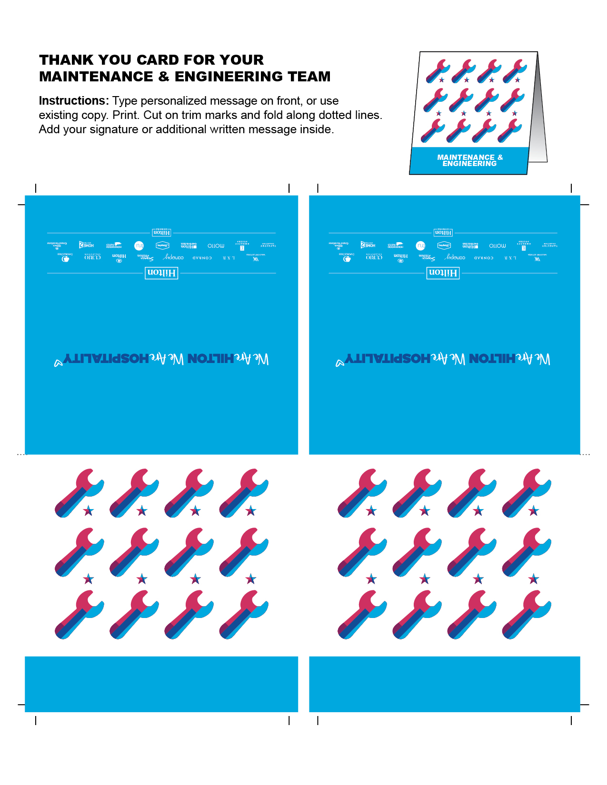

MAINTENANCE & ENGINEERING

MAINTENANCE & ENGINEERING