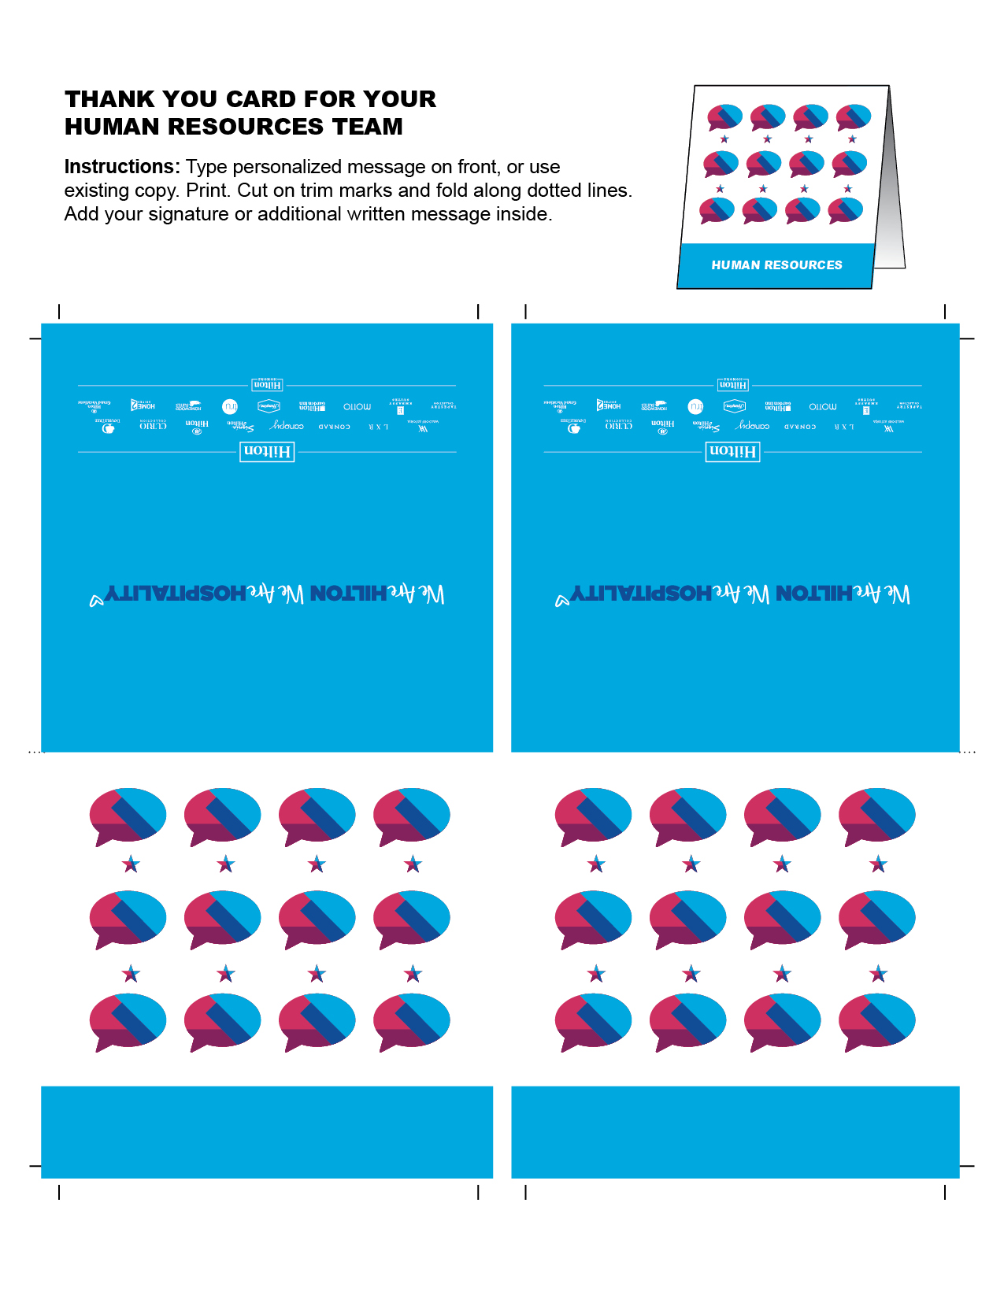

HUMAN RESOURCES

HUMAN RESOURCES